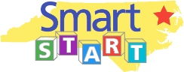

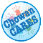

CHOWAN/PERQUIMANS SMART START PARTNERSHIP
409 Old Hertford Road, Edenton, NC 27932 252-482-3035
Mission: To enhance early childhood development and school readiness.
Susan Nixon, Executive Director MeShawn Hall, Early Education Director
Sarah Williams, Program Coordinator Shante White, Family Support Coordinator
Debbie Miller, Admin/Program Assistant September 2026

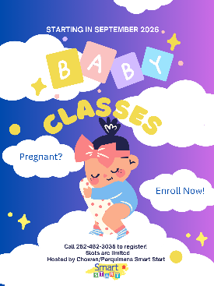
Healthy Mom, Healthy Baby Class starts September 17th
Pregnant? Sign up for our FREE BABY Class!
This program provides health education and specifically addresses topics for pregnant and new mothers (and fathers); such as labor and delivery, breastfeeding, postpartum depression, safe sleep, safety in the home and car, nutrition in the first year, and caring for an infant. Healthcare professionals from ECU Health Chowan Hospital, Albemarle Regional Health Services, ENC Peds Pediatrician, a former Labor and Delivery Nurse, Safe Kids Chowan County, and the Albemarle Maternal Mental Health Coalition partner with us to co-facilitate the classes with our staff.
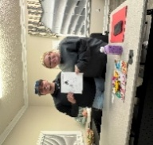
Topic-based incentives may be given at each class (for example a sleep sack for the Safe Sleep class), as well as information on local, regional, state, and national resources. Graduates receive a very nice ‘grow with the child’ car seat installed by a Safe Kids trained Car Seat Safety Technician. Two weeks or so after the due-date, we do a follow-up call with the mother to see how is she doing and to get the birth date and weight for our metrics. If there are any issues that the mother needs help with, we provide assistance in directing them to the proper agency at that time.
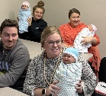
Classes are limited to ten mothers and their baby’s father, or other support person (such as a grandmother).
This class is funded by Blue Cross Blue Shield NC, ECU Health Chowan Hospital Community Benefits, and the North Carolina Partnership for Children (Smart Start).
Playgroup – Kaleidoscope Play & Learn helps Caregivers Promote School Readiness Skills
Parents, Caregivers, and Young Children in our Playgroup are provided weekly lessons centered around promoting early childhood development, healthy living, and school readiness skills. The Playgroup meets weekly at either the Perquimans County Library in Hertford or the Shepard Pruden Memorial Library in Edenton. Our facilitator, Shante White, provides a different lesson each week along with an activity that reinforces the lesson topic.
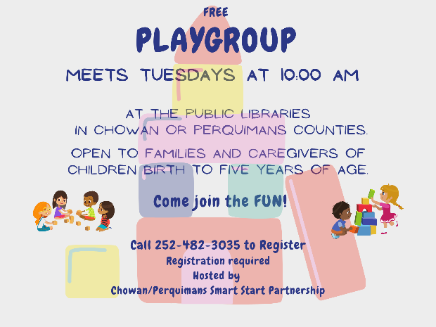
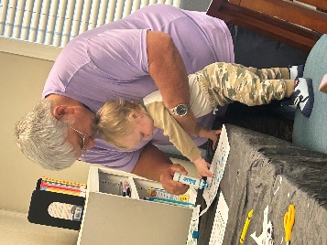
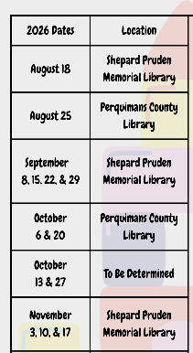
Call 252-482-3035 to register for our afternoon session – space is limited – so call today.
Developing Gross Motor Skills
Playing with bubbles is a fun activity that children like to do. Aside from adding lots of fun to a toddler’s day, bubbles have another purpose. They help to develop children’s gross motor skills in several ways. Playing with bubbles helps to develop gross motor skills in the areas of reaching, running and jumping, agility, kicking or stomping, hand-eye coordination, midline crossing, and hand/arm, foot/leg dominance.
- Reaching: Stretching and reaching work their arm and trunk muscles.
- Running and jumping: Chasing bubbles get their legs and feet moving.
- Agility: Dodging and catching bubbles strengthens balance and stability.
- Kicking or stomping: Using their feet and eyes together to stomp bubbles.
- Hand-eye coordination: Using eyes to track the bubbles and hands to catch them.
- Midline crossing: Grabbing for bubbles floating to their left and right strengthens the torso and improves
coordination across the body.
- Hand/arm, foot/leg dominance: Bubble play helps them to establish a dominant hand or foot.
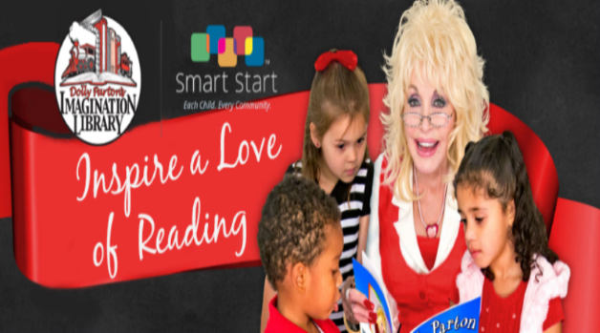
Copied from babysparks.com
Enroll your child today for a free book mailed every month until their 5th birthday!
Go to imaginationlibrary.com or call us at 252-482-3035

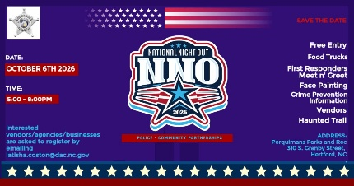
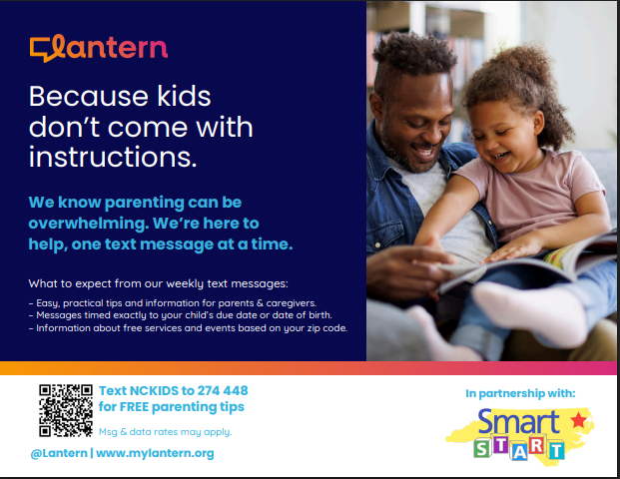
National Night Out
October 6th 2026
5:00 – 8:00 PM
Free Entry
Food Trucks/Vendors
Face Painting
Haunted Trail
First Responders - Meet n’ Greet
Perquimans Parks & Rec
310 S. Granby St.
Hertford
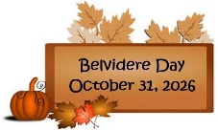
Upcoming Events!
For free activity ideas visit: teaching2and3yearolds.com, booksbythebushel.com,
Sesamestreet.org, pnc.com/grow-up-great, handsonaswegrow.com, and readaloud.org.
For informatic about community resources, call NC211, or contact Sarah Williams at 252-482-3035.

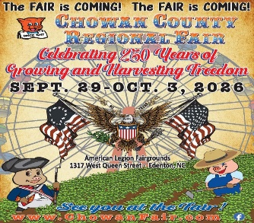
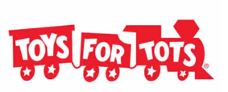
September 13th is National Grandparents Day
Toys for Tots Applications will be accepted October 1-31 only. Applications may be downloaded from our website or picked up from our office.

